**CS7301 - OOP Project**

# Rail Ticket Management System

**By**

***Vivek J Sudhakar***

***Reg. No: 2017103074***

***Ajai Sellappan***

***Reg. No: 2017103618***

Rail Ticket Management System

# Abstract

This project implements a simple Rail Ticket Management system. The software provides the following functionality:

1. User id/password based authentication
2. Ability to list available trains for a specified origin and destination stations
3. Ability to book tickets if tickets are available
4. List all past train bookings done by the user

The software has been written in Java using the Netbeans IDE. A postgres DB has been integrated using JDBC for DB access. The following tables have been created:

1. user_pwd: for user authentication
2. train_tt: to maintain Train Time Table
3. user_hist: to maintain train bookings done by the user

# UI Screens

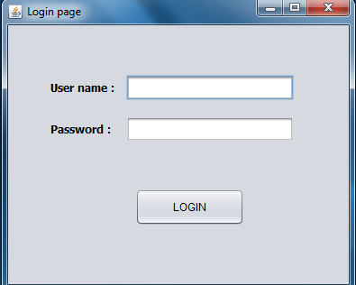

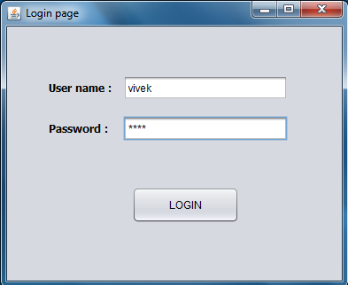

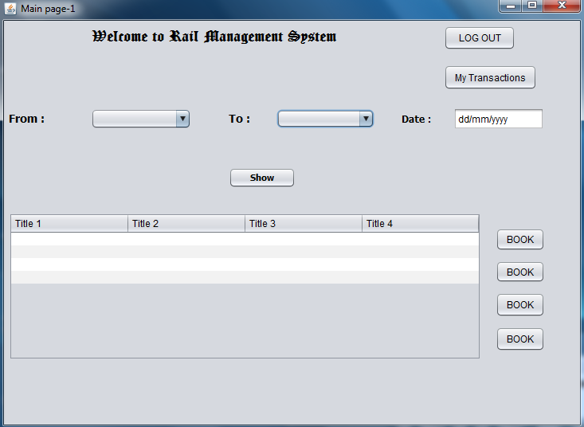

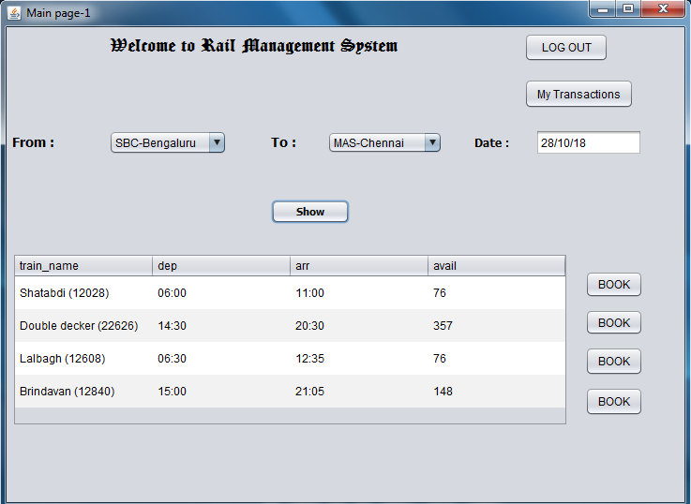

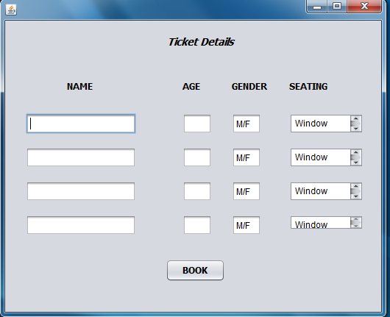

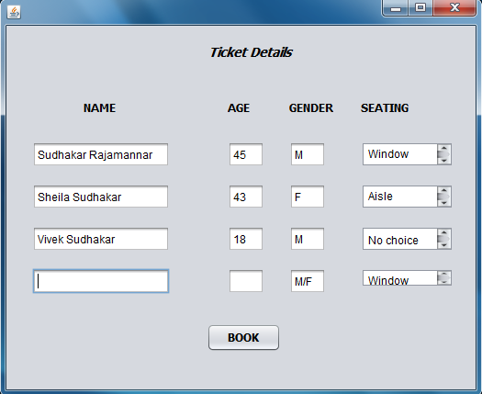

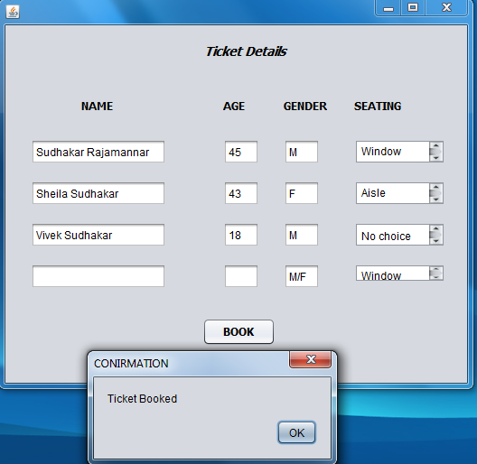

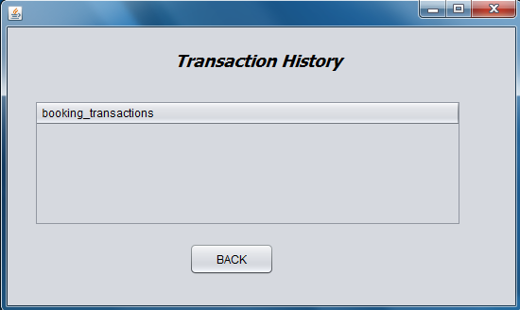

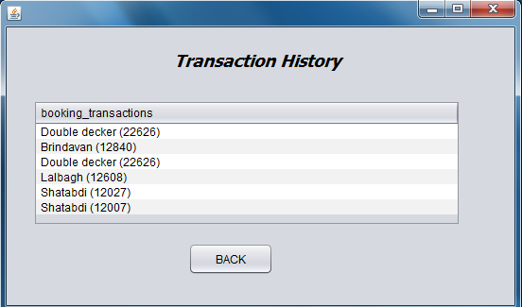

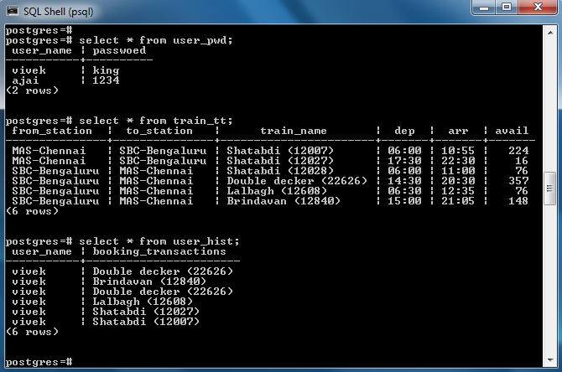

# Code

## Login page

private void jButton1ActionPerformed(java.awt.event.ActionEvent evt) {

Connection connection = null;

Statement statement = null;

ResultSet resultSet = null;

String s1=jTextField1.getText();

user=s1;

String s2="select * from user_pwd where user_name ='"+s1+"' ";

//System.out.println(s2);

try{

connection = DriverManager.getConnection(

"jdbc:postgresql://localhost:5432/postgres","postgres", "trrv1990");

statement=connection.createStatement();

resultSet=statement.executeQuery(s2);

char[] input=jPasswordField1.getPassword();

String s3= new String(input);

while(resultSet.next()){

if(s3.equals(resultSet.getString("passwoed")))

{

this.dispose();

new Mainscreen1().setVisible(true);

}

}

}catch(SQLException ex){

}finally

try {

resultSet.close();

statement.close();

connection.close();

} catch (SQLException ex) {

}

}

## Main screen1

**Show train names**

private void jButton1ActionPerformed(java.awt.event.ActionEvent evt) {

String s1=(String)jComboBox1.getSelectedItem();

String s2=(String)jComboBox2.getSelectedItem();

Connection connection = null;

Statement statement = null;

ResultSet resultSet = null;

String s3="select train_name,dep,arr,avail from train_tt where from_station='"+s1+"' and to_station='"+s2+"' ";

try{

connection = DriverManager.getConnection(

"jdbc:postgresql://localhost:5432/postgres","postgres", "trrv1990");

statement=connection.createStatement();

resultSet=statement.executeQuery

(s3);

jTable1.setRowHeight(35);

jTable1.setModel(DbUtils.resultSetToTableModel(resultSet));

}catch(SQLException ex){

}finally{

try {

resultSet.close();

statement.close();

connection.close();

} catch (SQLException ex) {

}

}

}

**Show past transactions**

private void jButton6ActionPerformed(java.awt.event.ActionEvent evt) {

Mainscreen3 obj = new Mainscreen3();

Connection connection = null;

Statement statement = null;

ResultSet resultSet = null;

String s4="select booking_transactions from user_hist where user_name='"+user+"'";

try{

connection = DriverManager.getConnection(

"jdbc:postgresql://localhost:5432/postgres","postgres", "trrv1990");

statement=connection.createStatement();

resultSet=statement.executeQuery

(s4);

Tran_table.setModel(DbUtils.resultSetToTableModel(resultSet));

}catch(SQLException ex){

}finally{

try {

resultSet.close();

statement.close();

connection.close();

} catch (SQLException ex) {

}

this.dispose();

obj.setVisible(true);

}

}

**Button to go to the booking page**

private void jButton2ActionPerformed(java.awt.event.ActionEvent evt) {

train_name=jTable1.getModel().getValueAt(0,0);

Trainname=train_name.toString();

this.dispose();

new Mainscreen2().setVisible(true);// TODO add your handling code here:

}

private void jButton4ActionPerformed(java.awt.event.ActionEvent evt) {

train_name=jTable1.getModel().getValueAt(2,0);

Trainname=train_name.toString();

this.dispose();

new Mainscreen2().setVisible(true); }

private void jButton3ActionPerformed(java.awt.event.ActionEvent evt) {

train_name=jTable1.getModel().getValueAt(1,0);

Trainname=train_name.toString();

this.dispose();

new Mainscreen2().setVisible(true); // TODO add your handling code here:

}

private void jButton5ActionPerformed(java.awt.event.ActionEvent evt) {

train_name=jTable1.getModel().getValueAt(3,0);

Trainname=train_name.toString();

this.dispose();

new Mainscreen2().setVisible(true); // TODO add your handling code here:

}

**Log out**

private void jButton7ActionPerformed(java.awt.event.ActionEvent evt) {

this.dispose();

new login().setVisible(true);// TODO add your handling code here:

}

## Mainscreen2

**To book ticket**

private void jButton2ActionPerformed(java.awt.event.ActionEvent evt) {

Connection connection = null;

Statement statement = null;

// ResultSet resultSet = null;

String s2="insert into user_hist values('"+user+"','"+Trainname+"')";

System.out.println(s2);

try{

connection = DriverManager.getConnection(

"jdbc:postgresql://localhost:5432/postgres","postgres", "trrv1990");

statement=connection.createStatement();

statement.executeUpdate(s2);

}

catch(SQLException ex){

}finally{

try {

// resultSet.close();

statement.close();

connection.close();

} catch (SQLException ex) {

}

JOptionPane.showMessageDialog(null,"Ticket Booked","CONIRMATION",JOptionPane.PLAIN_MESSAGE);

this.dispose();

new Mainscreen1().setVisible(true);

}

}